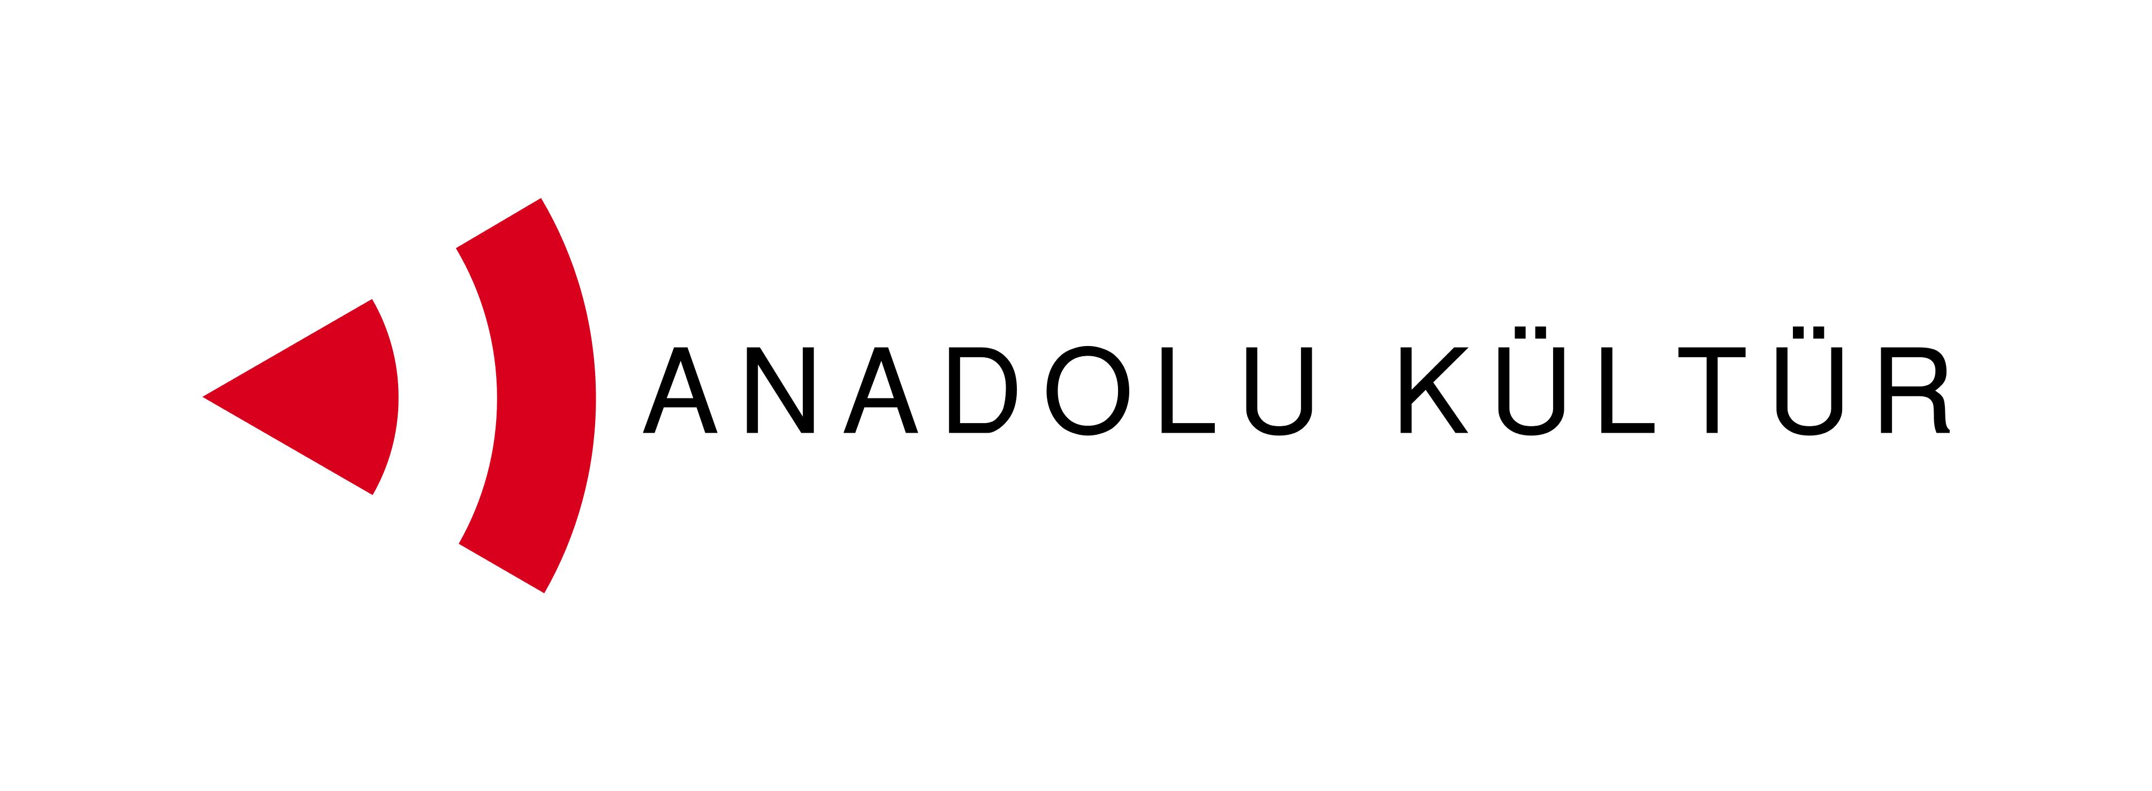
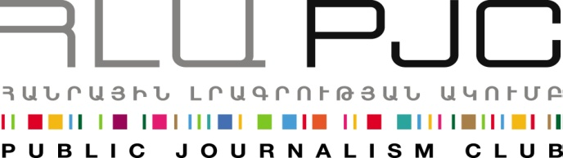

“Exchange of Painters” Project

Application Form

Deadline for submitting applications is July 25, 2014.
Please submit the completed application form to info@pjc.am
indicating "Exchange of Painters" in the Subject line.

1.Personal Information of the Mentor in charge of the exchange group

Name – Last Name *

Gender *

Date of Birth *

Address *

Country *

City *

E-mail address*

Phone number *

2. Education (please highlight the relevant one) *

BA
MA
Other
3. Name of the educational institution you are affiliated with as a mentor and position*

4. Exhibitions and Exchanges*
Have you participated in any of these:
- Solo Exhibitions (if yes, please provide the details in the space below)

- Group Exhibitions (if yes, please provide the details in the space below)

-Other art events, including international exchanges (if yes, please provide the details in the space below)

5.Do you have a personal website or blog? If not, where can we find your works? *

6. Proposed group of 4 students to participate in the event: *
Please list the four participants of the group below and attach their CV to include the following information at minimum: full name, gender, date of birth; country and city, education, languages, contact info and any other, if relevant.

5. Motivation*
(In not more than 250 words elaborate on why this exchange is important for you and your group.)

6. Language proficiency (This is not considered as a selection criterion)*

Language | Beginner | Basic | Intermediate | Good | Excellent

Deadline for submitting applications is July 25, 2014.

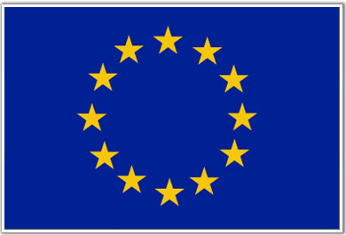
Exchange of Painters project takes place within the framework of the programme Support to the Armenia-Turkey Normalisation Process funded by the European Union

Support to the Armenia-Turkey Normalisation Process
Support to the Armenia-Turkey Normalisation Process is a programme implemented by a Consortium of eight civil society organisations from both countries with the financial assistance of the European Union under the Instrument for Stability.
The overall objective of the programme is to promote civil society efforts towards the normalisation of relations between Turkey and Armenia and towards an open border by enhancing people-to-people contacts, expanding economic and business links, promoting cultural and educational activities, facilitating access to balanced information in both societies.
The Consortium members include Civilitas Foundation (CF), Eurasia Partnership Foundation (EPF), Public Journalism Club (PJC), Regional Studies Center (RSC) from Armenia; and Anadolu Kültür, the Economic Policy Research Foundation of Turkey (TEPAV), Helsinki Citizens’ Assembly (hCa), and Hrant Dink Foundation from Turkey.

Public Journalism Club
Public Journalism Club (PJC) was established in March 2011, in Yerevan, Armenia, unifying journalists, social media experts, and advocates around collaboration between new technologies and media. The organisation's mission is to promote freedom of expression, diversity and pluralism in Armenia developing participatory and public journalism by bridging public reporters and professional journalists, mass media and social media, IT and social sector specialists.
During 3 years of performance PJC has managed to form a positive reputation in the field by successfully implementing a few targeted innovative, and breakthrough projects such as www.mynews.am public reporting platform and Hackathon{YAN}contest of innovative ideas, where PJC is a co-founder and co-initiator. Media Center is another accomplished project that has served for already one year to the mission of developing competent debate culture in Armenia and establishing collaborative expanding communication between civil, social, state and international sectors.

Anadolu Kültür
Anadolu Kültür was founded as a not-for-profit cultural institution in 2002 when individuals from various fields of the art world, the business world and civil society came together to support the production and sharing of culture and art in cities across Turkey and abroad.
Anadolu Kültür continues its activities with the belief that cultural and artistic exchange will help develop mutual understanding and dialogue and overcome regional differences and prejudices, and that a broader cultural life will elicit a discussion of concepts such as citizenship, identity and belonging. Anadolu Kültür’s vision is the dream of a society that has managed to shed its prejudices, that finds nourishment and enrichment through differences and where cultural diversity is not perceived as a source of conflict but wealth. Anadolu Kültür aims to build bridges between different ethnic, religious and regional groups by sharing culture and art, supporting regional initiatives, emphasizing cultural diversity and cultural rights and consolidating interregional collaboration.
For further information please contact
Public Journalism Club  Address: Yerevan, 0002, 30 Saryan street, 2nd floor, Armenia  Phone: +37499 755 898, +37460 505898  E-mail: info@pjc.am  Web-site: www.pjc.am  Twitter: @pubjournclub  Facebook: http://goo.gl/cQxcMb | Anadolu Kültür  Address: Cumhuriyet Ave. No: 40, Ka-Han, 8th Floor, Elmadağ 34367, İstanbul, Turkey  Phone/Fax: + 90 212 246 76 08  E-mail: iletisim@anadolukultur.org  Facebook: https://www.facebook.com/anadolukultur  Twitter: @anadolu_kultur  Video Channel: http://vimeo.com/user4333654  Website: www.anadolukultur.org

