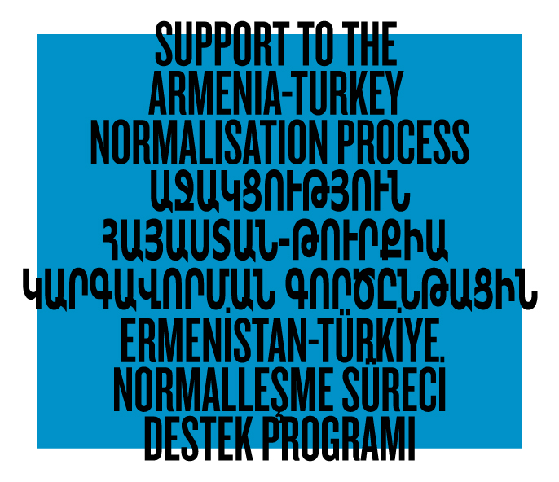

ADDENDUM to Terms of Reference

Evaluation of the EU-funded Programme

“Support to the Armenia-Turkey Normalisation Process”

June 10, 2015

- The location of organizations and citizenship of individuals who are applying to this TOR do not matter.

- EPF does not have a specific template for the proposal; there is no limitation on the number of pages. At the same time, the volume of the comprehensive analytical report should be in the range of 15 to 25 pages (without annexes).

- For in-depth interviews, applicants can consider a group of about 10-15 people in each country.

- For focus-groups, applicants can consider a group of about 10 or 20 people in each country.

- To further understand the volume of the expected work, applicants can refer to the web-site of the programme at http://www.armenia-turkey.net

- To see the brief descriptions of projects implemented by the members of the Consortium please go to this page: http://www.armenia-turkey.net/en/projects,
- To see the brief descriptions of projects supported under the Grant Scheme please go to this page: http://www.armenia-turkey.net/en/projects-approved

- The volume of internal documents that the selected candidate will need to consider is about 20 to 50 pages each; the Programme has only three or four documents of that size that the selected candidate should consider.

END

