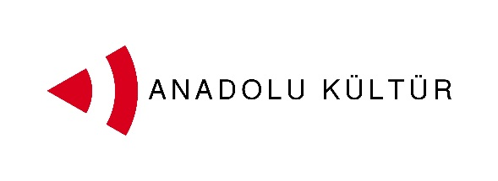
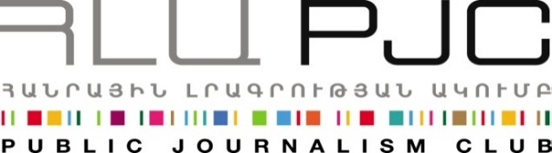
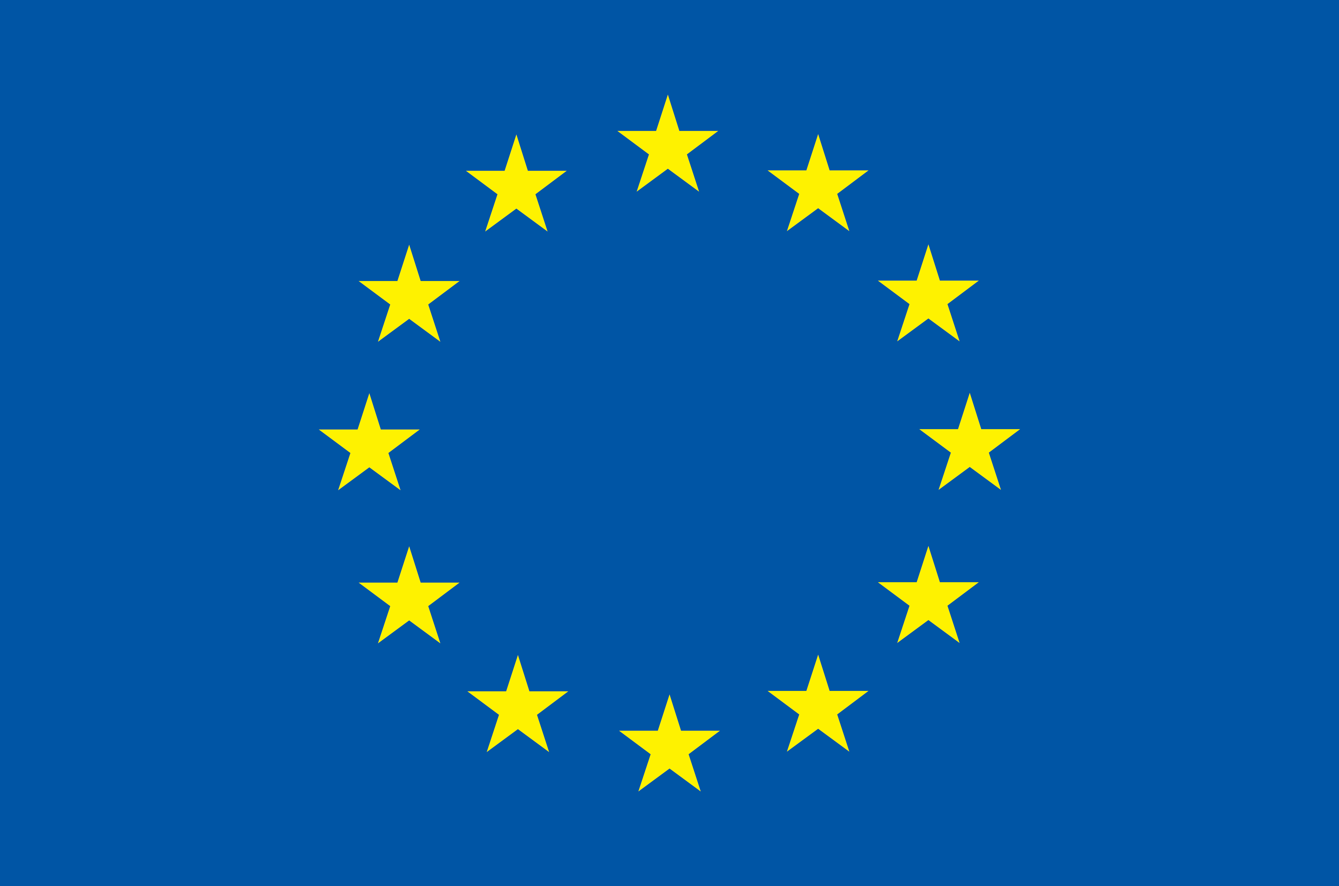
European Union

Press Announcement
Exchange or Painters Project Kicks off
Yerevan, September 01, 2014: The Public Journalism Club (PJC) launched the Exchange of Painters project at Akanat Private Gallery-Café on September 1st. Exchange of Painters project is implemented by PJC (Armenia) in partnership with Anadolu Kültür (Turkey) within the framework of the programme “Support to the Armenia-Turkey Normalisation Process” financed by the European Union.
A group of four young artists led by mentor Serdar Yılmaz from Turkey and a similar group under the guidance of mentor Gagik Charchyan from Armenia were selected through an open call to participate in the project.
The exchange project was kicked off with a joint exhibition of the works by participants from Armenia and Turkey. The exhibition will remain on display at Akanat Gallery-Café until the end of the exchange on September 7th.
Seda Muradyan, president of Public Journalism Club introduced the overall project and the guests. She noted, “Every country is the palpable illustration of its culture since without culture a country is a mere geographic area. To turn our countries into something more than mere geographic areas with closed borders for our two societies the Public Journalism Club, in partnership with Anadolu Kültür, initiated the “Exchange of Painters” project.”
Dirk Lorenz, Charge d'Affaires at the Delegation of the European Union to Armenia delivered an opening speech during the event. The EU representative noted that culture is one of the best tools of enhancing dialogue between the two states since the language of art is universal and said “Reconciliation is possible notwithstanding the closed borders.”
Painters Serdar Yılmaz and Gagik Charchyan each presented their teams and spoke about their expectations of the project.
Speaking about the impact of the project Gagik Charchyan said, “For me it is important that artists from different countries have direct contacts without mitigation. This is how they search for and formulate universal concepts in culture and produce unrestricted ideas and new environments outside of the existing dominating concepts. ” Continuing on Charchyan’s idea, Serdar Yılmaz added,
"Art is the language to understand and expose ourselves truly. Communication through painting with young artists both from Armenia and Turkey excites me a lot. I hope the friendships formed during these workshops and collesiums will help to open new dialogues between the people of Armenia and Turkey and do away with boundaries that hitherto exist."
Culture is one of the possible tracks for promoting dialogue between the societies of Armenia and Turkey. More specifically, artistic activity can help an effective interchange since it does not need translation and mediation, and it transmits messages and creates bonds using the universal language of art. With this in mind, the Public Journalism Club, in partnership with Anadolu Kültür, has launched the “Exchange of Painters” project focusing on the role of art in promoting Armenia-Turkey relations.
For inquires on project details please contact Ester Hakobyan at estherhakobyan@pjc.am and 098540804:

Exchange of Painters takes place within the framework of the programme
Support to the Armenia-Turkey Normalisation Process funded by the European Union

Support to the Armenia-Turkey Normalisation Process is a Programme implemented by a Consortium of eight civil society organisations from both countries with the financial assistance of the European Union under the Instrument for Stability.
The overall objective of the Programme is to promote civil society efforts towards the normalisation of relations between Turkey and Armenia and towards an open border by enhancing people-to-people contacts, expanding economic and business links, promoting cultural and educational activities and facilitating access to balanced information in both societies.
The Consortium partners include Civilitas Foundation (CF), Eurasia Partnership Foundation (EPF), Public Journalism Club (PJC), Regional Studies Center (RSC) from Armenia; and AnadoluKültür, the Economic Policy Research Foundation of Turkey (TEPAV), Helsinki Citizens’ Assembly (hCa), and Hrant Dink Foundation from Turkey.
For further details on the programme and the project, please visit www.armenia-turkey.net

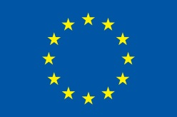

Support to the Armenia-Turkey Normalisation Process is funded by the European Union

For further information please contact
Public Journalism Club
Address: Yerevan, 0002, 30 Saryanstreet, 2nd floor, Armenia
Phone: +37499 755 898, +37460 505898
E-mail: info@pjc.am
Web-site:www.pjc.am
Twitter: @pubjournclub
Facebook:http://goo.gl/cQxcMb

