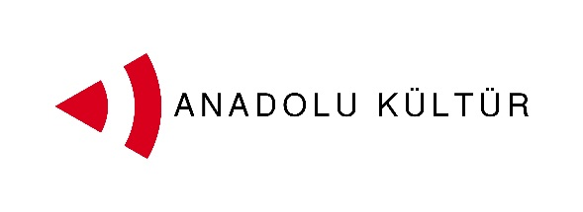
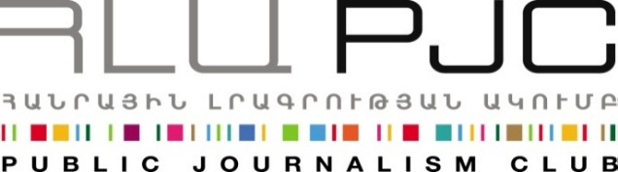
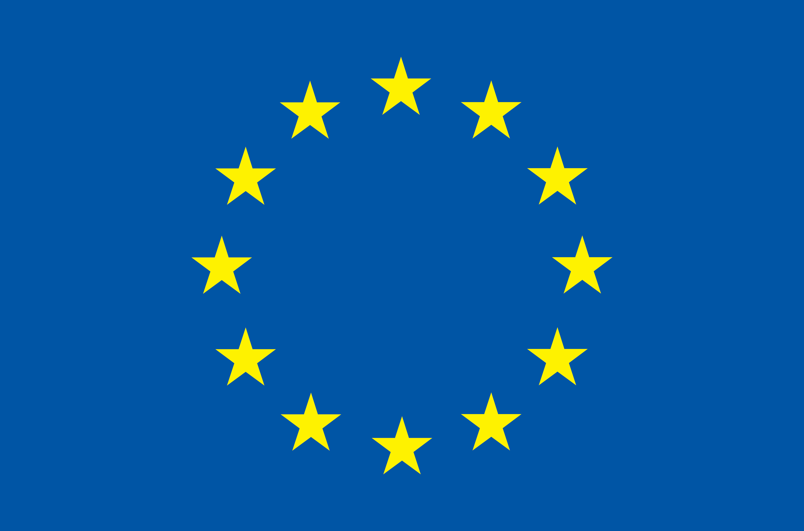
European Union

Press Release
“Exchange of Painters” Project Participants: Second Day in Yerevan
Yerevan, 02.09. 2014:On September 2ndthe young painters from Turkey and Armenia participating in the “Exchange of Painters” project had a unique architectural tour of Yerevan. Under the guidance of artist Vahram Aghasyan. The participants got to know the architecture of the capital, various stages of urban development, as well as its different districts, including cultural and industrial centers and residential areas. They visited the Northern Avenue and Kond, Norashen and Vahakni districts thus getting to see the architectural and social terrain of Yervan.
. Alongside with the visit to the Yerevan History Museum the previous day, the tour allowed the participants to get to know the history, culture, traditions and residents of Yerevan, as well as prepare for the public open air session entitled “Yerevan and its Residents”.
The tour of Yerevan ended at MEGERYAN CARPETS where the participants had an opportunity to learn about and observe in practice Armenia’s rich tradition of carpet making.
The second day of the exchange project ended at the Fine Arts High School at Mkhitar Sebastatsi Educational Complex, where a master class entitled “Overview of Armenian Fine Arts”, was delivered by painter Arman Grigoryan. The master class presenting various directions and phases of fine arts focused on modern and contemporary art in Armenia. This followed the visit to the National Gallery of Armenia, thus contributing to the understanding of Turkish painters about Armenia’s rich arts heritage.
Arman Grigoryan, who delivered the master class, lives and works in Yerevan as a lecturer at Fine Arts High School at Mkhitar Sebastatsti Educational Complex and the Institute of Contemporary Arts. Grigoryan was one of the pioneers of avant-garde arts in Armenia in the late 1980s. In 1987, Grigoryan together with his friends organized the notorious “Third Floor” exhibition which was a revolution in the academic art environment. His individual exhibitions include one held in Le Cent Quatre in Paris (1991) and “Bad Religion” held at Ch. Khachaturyan Gallery in Yerevan (1997). In 1997 his work was presented at the 47th Venice Biennale. Grigoryan’s works have featured in a number of group exhibitions.
The project was launched on September 1 and its activities will continue through September 7.
Culture is one of the possible tracks for promoting dialogue between the societies of Armenia and Turkey. More specifically, artistic activity can help an effective interchange since it does not need translation and mediation, and it transmits messages and creates bonds using the universal language of art. With this in mind the Public Journalism Club, in partnership with AnadoluKültür, has launched the “Exchange of Painters” project focusing on the role of art in promoting Armenia-Turkey relations.

The project was launched on September 1 and its activities will continue through September 7.
Culture is one of the possible tracks for promoting dialogue between the societies of Armenia and Turkey. More specifically, artistic activity can help an effective interchange since it does not need translation and mediation, and it transmits messages and creates bonds using the universal language of art. With this in mind the Public Journalism Club, in partnership with AnadoluKültür, has launched the “Exchange of Painters” project focusing on the role of art in promoting Armenia-Turkey relations.
For inquires on project details please contact Ester Hakobyan at estherhakobyan@pjc.am and 098540804:
Public Journalism Club. mailto:info@pjc.am or call + 37460 505 898.
***
Support to the Armenia-Turkey Normalisation Process is a Programme implemented by a Consortium of eight civil society organisations from both countries with the financial assistance of the European Union under the Instrument for Stability.
The overall objective of the Programme is to promote civil society efforts towards the normalisation of relations between Turkey and Armenia and towards an open border by enhancing people-to-people contacts, expanding economic and business links, promoting cultural and educational activities and facilitating access to balanced information in both societies.
The Consortium partners include Civilitas Foundation (CF), Eurasia Partnership Foundation (EPF), Public Journalism Club (PJC), Regional Studies Center (RSC) from Armenia; and AnadoluKültür, the Economic Policy Research Foundation of Turkey (TEPAV), Helsinki Citizens’ Assembly (hCa), and Hrant Dink Foundation from Turkey.
For further details on the programme and the project, please visit www.armenia-turkey.net

