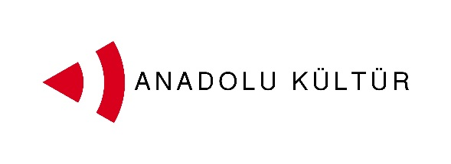
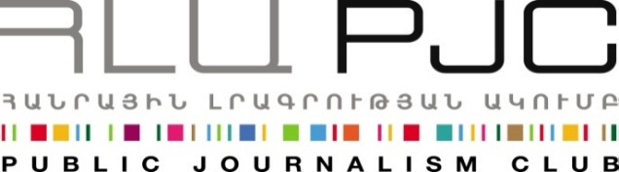
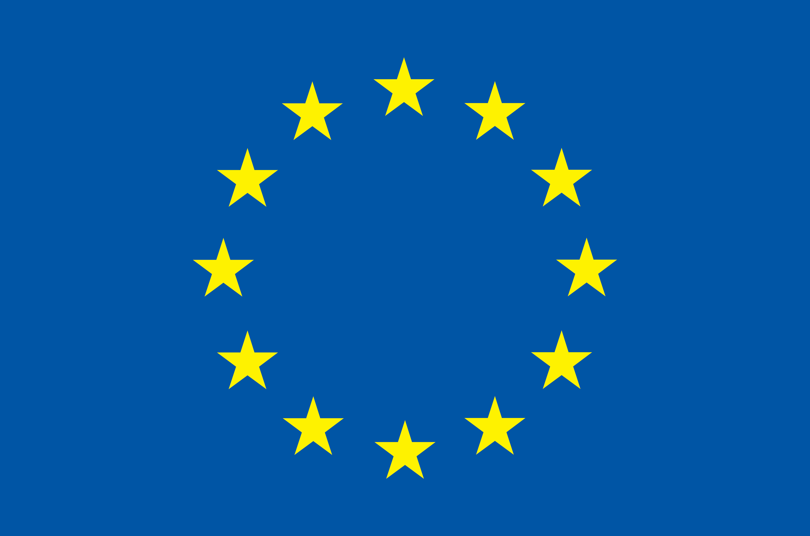
Programme funded by the European Union

Press Release
Second Stage of “Exchange of Painters” Project Kicks Off in Istanbul
Istanbul, September 26, 2014. On September 29th the participants of the “Exchange of Painters” project will once again come together, this time in Istanbul. Following the first stage of the project in Armenia, the group of eight young artists from Armenia and Turkey led by their mentors Gagik Charchyan and Serdar Yılmaz will have more opportunities to work and learn together through a number of sketching events, museum and gallery visits and master classes to be held for them in Istanbul.
The Istanbul stage of the project will be officially launched on September 30th at a reception to be held at Cezayir (Hayriye Cad. No: 12, Galatasaray, Beyoğlu).
The exchange programme in Istanbul will include tours to old Istanbul districts, the Historical Peninsula and the sites of Armenian Architecture.
On October 1st, the participants will spend the whole day on the island Heybeliada sketching its beautiful sites. The programme will include visits to art galleries and museums such as the DEPO, the SALT, the Istanbul Modern as well as Dolmabahçe Museum.
Master classes for the participants will be held by Gülçin Aksoy, a professor at Mimar Sinan Fine Art University and Fırat Arapoğlu, a renowned art historian. Gagik Charchyan, the mentor of the Armenia group will also hold a master class for group members and other art students from Istanbul.
The first part of the exchange took place in Armenia between September 1- 7. It started with the opening ceremony at Akanat Café-Gallery, attended by around 50 guests and featured the launch of the exhibition of works by participating young painters. During the first and second days of the programme, the participants visited the Yerevan History Museum and had an architectural tour of the city thus getting to know the capital and preparing for on open-air session where they painted Yerevan and its residents. Trips to temple Garni, Geghard monastery and Gyumri, the second largest city of Armenia, were also included in the programme.
Master Classes were delivered by Armenian painters Arman Grigoryan, Peto Poghosyan and Karen Barseghyan, Art Lab Studio and artist Vahram Aghasyan. Serdar Yılmaz conducted a master class for more than 60 students of Panos Terlemezyan Art College on September 5th0.
On the sixth day of the exchange, both groups worked together to paint an arch in downtown Yerevan using Street Art concepts and technologies that reflected their vision for open borders. On the last day of the event, the participants came together at a reflection session to summarize the experiences of the 7-day visit to Armenia.
Over 20 sketches were produced during the first stage of the visit in Armenia, some of which will be placed in a 2015 calendar together with the sketches/paintings to be produced in Istanbul.
Culture is one of the possible tracks for promoting dialogue between the societies of Armenia and Turkey. More specifically, artistic activity can help an effective interchange since it does not need translation and mediation, and it transmits messages and creates bonds using the universal language of art. With this in mind the Public Journalism Club, in partnership with Anadolu Kültür, has launched the “Exchange of Painters” project focusing on the role of art in promoting Armenia-Turkey relations.
For inquires on project details please contact Ester Hakobyan at estherhakobyan@pjc.am and 098540804:

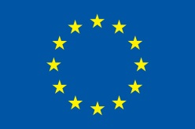

Exchange of Painters takes place within the framework of the programme
Support to the Armenia-Turkey Normalisation Process funded by the European Union
www.armenia-turkey.net

***

Support to the Armenia-Turkey Normalisation Process is a Programme implemented by a Consortium of eight civil society organisations from both countries with the financial assistance of the European Union under the Instrument for Stability.

The overall objective of the Programme is to promote civil society efforts towards the normalisation of relations between Turkey and Armenia and towards an open border by enhancing people-to-people contacts, expanding economic and business links, promoting cultural and educational activities and facilitating access to balanced information in both societies.

The Consortium partners include Civilitas Foundation (CF), Eurasia Partnership Foundation (EPF), Public Journalism Club (PJC), Regional Studies Center (RSC) from Armenia; and Anadolu Kültür, the Economic Policy Research Foundation of Turkey (TEPAV), Helsinki Citizens’ Assembly (hCa), and Hrant Dink Foundation from Turkey.

Support to the Armenia-Turkey Normalisation Process is funded by the European Union

For further information please contact
Public Journalism Club
Address: Yerevan, 0002, 30 Saryan street, 2nd floor, Armenia
Phone: +37499 755 898, +37460 505898
E-mail: info@pjc.am
Web-site: www.pjc.am
Twitter: @pubjournclub
Facebook: http://goo.gl/cQxcMb

