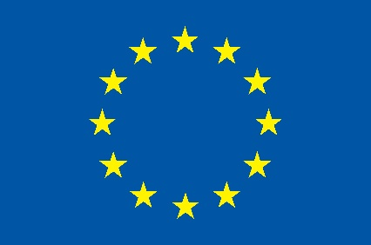 | Support to the Armenia-Turkey  Normalisation Process  European Union Initiative | 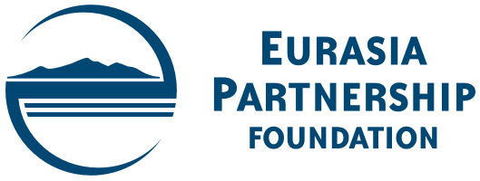 | 

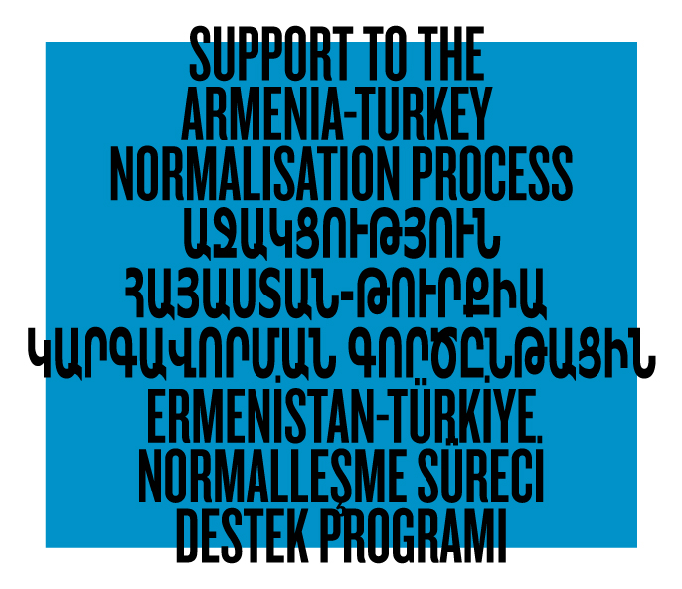

SUB-GRANT SCHEME

Guidelines for Grant Applicants

Overview

Support to the Armenia-Turkey Normalisation Process (ATNP) is a Programme implemented by a Consortium of eight civil society organisations from Armenia and Turkey with the financial assistance of the European Union under the Instrument contributing to Stability and Peace (IcSP) and the Swedish Ministry for Foreign Affairs under the Bridge Funding to ATNP. The Consortium partners are Civilitas Foundation (CF), Eurasia Partnership Foundation (EPF), Public Journalism Club (PJC), Regional Studies Center (RSC) from Armenia; and Anadolu Kültür, the Economic Policy Research Foundation of Turkey (TEPAV), Citizens’ Assembly (CA), and Hrant Dink Foundation (HDF) from Turkey.

The Programme’s overall objective is to empower and engage civil societies of Turkey and Armenia to contribute to the enhanced regional peace and stability, democratic pluralism and social inclusion across and within their societies. This will be achieved through engaging new actors in economic, cultural, educational, and awareness-raising activities between Armenia and Turkey, and improving information flow, communication exchange and networking between media, expert communities and institutions

One of the main pillars of the Programme is inclusiveness – to engage and support new actors in the dialogue process. To this end, the Consortium created a Sub-grant Scheme to invite individuals and organisations - other than the Consortium members - to propose and implement their own projects that have a potential to significantly contribute to the overall objective of the Programme and multiply the shared outcomes. The Sub-grant Scheme will allow the Consortium to engage a larger group of stakeholders in the Programme activities and increase its impact.

The total available fund in the Grant Scheme is € 80,000. The Sub-grant Scheme will support proposals up to eight months of duration with a budget ranging from € 5,000 to € 20,000. In total, the Consortium expects to award from 4 to 8 sub-grants.

The Sub-grant Scheme may support the overall budget of submitted proposals without co-funding requirement. However, the Sub-grant Scheme may also co-finance projects-in-progress or projects that are about to start with support from donors other than the European Union and the Swedish Ministry of Foreign Affairs. In case the submitted proposal requests co-funding for a project that has not yet started, the co-funding will be possible as long as a) the other confirmed or pending source of funding is specified in the application form; b) the requested funds from the Sub-grant Scheme are clearly specified and justified, and c) the visibility of the EU, Swedish Ministry of Foreign Affairs and the Consortium is ensured.

Eligibility

- Applications are welcome from civil society organisations and individuals other than the Consortium partners. Individuals will have to participate in the pre-grant meeting at HDF (for the applicants from Turkey) or EPF (for the applicants from Armenia) to provide clear division of tasks and responsibilities for the project implementation. The Sub-grant Scheme may also provide grants to profit-making organisations in case the grant funds contribute to the overall objective of the Programme and not used to make profit. Applicant organisations should have a formal registration either in Armenia or in Turkey. Individual applicants should be either citizens of Armenia or Turkey or should have permanent residency in Armenia or Turkey.

- Governmental/public agencies and political entities are not eligible to apply.

- Eligible Costs include project-related expenses, such as a) personnel salary (e.g. project director, coordinator, accountant, etc.) and honoraria for experts (local and/or international); b) communication costs (phone, internet); c) travel costs (transportation, accommodation, meals); d) purchase of a limited amount of equipment (computer, software, etc.) and stationary necessary to realise the project; e) survey and publication expenses; f) rental of conference facilities, translation equipment, etc.; g) other expenses directly related to project implementation. The Sub-grant Scheme beneficiaries will not be issued VAT exemption certificate by the authorities in Armenia and Turkey. Therefore, as an exception, their VAT will be considered as an eligible cost by the EU and the Swedish Ministry of Foreign Affairs.

- Activities of proposed projects should take place either in Armenia or Turkey or both. In case, additional/different project locations are proposed, applicants should explain the need in the application.

Timeline

Armenia-based applicants should submit their applications to Eurasia Partnership Foundation (Armenia). Turkey-based applicants should submit their applications to Hrant Dink Foundation (Turkey). The language of applications is English. The opportunity is open from the date of the publication of this announcement till December 18, 2017. Applications submitted by this deadline will receive Consortium’s feedback in January 2018. In this case, projects can start in February 2018 with the final date of activities being October 31, 2018.

Selection Criteria and Selection Procedure

Eurasia Partnership Foundation (EPF) (Armenia) that has 20 years of experience in programme administration and grant-making will bear the ultimate responsibility for the administration of the Sub-grant Scheme. Hrant Dink Foundation (HDF) (Turkey) will be the focal point in Turkey regarding the administration of the Sub-grant Scheme. EPF and HDF will collect the submitted applications in Armenia and Turkey respectively.

Submitted applications will be considered by an Evaluation Committee, comprising designated representatives from all members of the Consortium; representatives of the European Union and Swedish Ministry for Foreign Affairs may participate in an observer capacity. The initial check will be over the technical criteria - the proposal language, eligibility of the applicant, project duration and location, and amount of requested funding. Proposals shortlisted after technical eligibility check will be further considered by the Evaluation Committee.

The selection criteria upon which the Evaluation Committee will consider the applications include the following:

- Does the project contribute to the overall objective of the Programme Support to the Armenia-Turkey Normalisation Process?
- Is the project relevant to the particular needs and constraints of the target groups it is addressing?
- Does the project include partnership between Armenia- and Turkey-based individuals and/or organisations?
- Does the project propose a minimum level of sustainability for the effort after the end of funding?
- Is the project innovative and does it offer an added value?
- Is the budget realistic and consistent with the proposed project?
- Does the applicant have enough capacity to successfully implement the proposed project?

While considering the applications, the Evaluation Committee may contact the applicant(s) for additional information and/or clarification.

Only those applications that receive the unanimous support of all the eight members of the Evaluation Committee will be recommended for funding. In case the Committee is unable to make a final decision on a particular application, it may condition the final approval upon the agreement of the applicant to introduce certain modifications in the action plan and/or budget. In this case, the applicant will be given a reasonable time (up to two weeks) to re-submit the proposal, and the Evaluation Committee will assess the re-submitted proposal before confirming unanimous support.

Grant Award

Within a month after the award notification, the sub-grantee organisations and/or individuals will be invited to attend a Grants Management (GM) seminar. The GM seminar for the Armenia-located grantees will be held at EPF, while the GM seminar for the Turkey-located grantees will be held at HDF with participation of the EPF Grants Manager. The Armenia- and Turkey-based partners of the Turkey- and Armenia-based grantees will also be requested to attend the GM seminars in their home countries to get acquainted with the basic rules and procedures that EPF will apply to ensure proper financial and programmatic management of their projects.

Following the GM seminar, each sub-grantee will sign a Grant Agreement with EPF.

Publicity

The Consortium will ensure the publicity of the funded projects.

The sub-grantees will be included in the pool of Consortium contacts to receive updates on the Programme, invitations to the Consortium events, and other relevant information.

During the entire period of their projects, the sub-grantees will be obliged to follow the EU marking and branding procedures put forward in the EU Communication and Visibility Manual, as well as the visibility requirements of the Swedish Ministry of Foreign Affairs, unless otherwise requested from and approved by the EU and the Swedish Ministry of Foreign Affairs. The sub-grantees will also mention that their projects are supported by the Sub-grant Scheme within the framework of the programme Support to the Armenia-Turkey Normalisation Process funded by the European Union and the Swedish Ministry for Foreign Affairs.

Other Considerations

The Consortium reserves the right to require that the sub-grantee include an audit of the grant funds in the budget of its project; however, the total budget of the project (including an audit expense) cannot be higher than € 20,000.

In case the Consortium does not receive enough number of quality applications by the designated submission deadline – December 18, 2017, the Consortium reserves the right, upon the approval of the Swedish Ministry for Foreign Affairs, to re-allocate the remaining funds to those approved projects of the Sub-grant Scheme that need additional funding or have the potential to expand or sustain their activities. If this option is not possible, the Consortium reserves the right to re-allocate the remaining funds to support other aspects of the programme Support to the Armenia-Turkey Normalisation Process upon approval from the Swedish Ministry for Foreign Affairs.

Submission Procedure

An application should include the following documents:

- Application Form (proposal)
- Budget
- Grants Management Questionnaire (for legal entities only)

Applicants should fill out the enclosed Application Form, Budget, and the Grants Management Questionnaire (for legal entities only) in English.

In case the applicant is a legal entity, the application package should include scanned (PDF) copies of the Application Form, Budget, and Grant Management Questionnaire all featuring the signature of the head of the applicant organisation and the seal of the organisation, as well as other requested supporting documents. In case, the applicant is an individual, the application package should include scanned (PDF) copies of the Application Form and Budget both featuring the signature of the individual applicant, as well as the copy of his/her passport as supporting document.

Armenia-based applicants should submit their application packages electronically to Eurasia Partnership Foundation (Armenia) at grants@epfound.am.

Turkey-based applicants should submit their application packages to Hrant Dink Foundation (Turkey) at grants@hrantdink.org

Armenia-based applicants can address their inquiries to Ms. Lusine Avagyan at +374 10 25 15 75 (ext. 118) or lavagyan@epfound.am

Turkey-based applicants can address their inquiries to Mr. Çağdaş Özbakan at +90 212 240 33 61 (ext. 227) or cagdasozbakan@hrantdink.org

