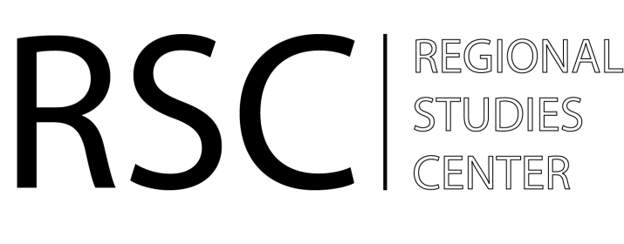
Regional Studies Center (RSC)
Yerevan, Armenia

RSC SUMMARY OVERVIEW
ARMENIA-TURKEY YOUTH TRAINING

“Closed Borders, Open Minds: Part Two”
Istanbul, Turkey
13-19 October 2014

After a successful first part of a two-phase training course entitled, “Closed Borders, Open Minds,” in Yerevan from 12-19 May 2014, with twenty participants from Armenia and Turkey, the second, follow-up training was held in Istanbul from 13-19 October 2014.

In partnership with the Civic Forum NGO, a recognized leader in the field of youth education and training, the second phase of the RSC youth training focused on the deepening of participants’ knowledge, developing their skills and shaping a more positive opinion and political context of the Armenia-Turkey normalisation process. The training course also featured visits to the Hrant Dink Foundation and the offices of the “Agos” newspaper.

More specifically, the core objectives of the “Closed Borders, Open Minds: Part Two” training course included:
- the deepening of participants’ understanding of the key concepts on conflict management/transformation and peace-building efforts;
- providing greater exposure to new concepts of designing initiatives/projects which could promote the Armenia-Turkey normalisation process, at least on the civil society level;
- developing and presenting a common vision of the normalisation process and its final outcomes;
- The “mapping” of potential resources for joint efforts to contribute to a shared, common vision of Armenia-Turkey normalisation.

Led by freelance trainer Bianca Cseke (Romania) and the president of the Civic Forum NGO, Marine Manucharyan (Armenia), the training course utilized a non-formal education methodology, including working in small groups, debates, discussions and presentations. The following topics were covered during the training:
- Sharing of experience and exploring the Theory of Conflict – Violence –Peace;
- A conflict mapping exercise, including the collective mapping of actors and relations and conflict assessment tools;
- Building a Vision of the desired future – power brainstorming;
- Introduction of Armenia-Turkey initiatives;
- Collaborative exploration of the Theory of Change;
- The development of project ideas and initiatives in the groups, with related presentations.

Participants from Armenia

Manushak Kiloian, International relations student, Yerevan State University
Hayk Sayadyan, Director, "City Guide" LLC
Julia Sahakyan, Fellow, Caucasus Research Resource Center
Armen Melkonyan, Human Rights and Conflicts Research Institute NGO, Gyumri
Levon Minasyan, Art Director, Domino Production
Vahe Khumaryan, MA student, University of Tartu & Russian-Armenian Slavonic University
Astghik Mirzabekyan, Marketing Manager, "X-Art" LLC, Center of Digital Technologies
Ani Poghosyan, Project Assistant, World Vision Armenia

Participants from Turkey

Gurkan Ozturan, Member of JEF-Turkey, citizen journalist, political analyst
Gökhan Çoğalırlar, member of Youth Participation and Intercultural Dialogue Association, freelance translator
Aysun Senlı, Intern, the Center for International and European Studies, Kadir Has University
Fatma Özkaya, MA student, Mimar Sinan University
Berivan Akin, Lecturer, Gediz University, Izmir
Özge Nur Öğütcü, Specialist, the Center for Eurasian Studies, Ankara
Eki Oğulcan, Mining Engineering student, Hacettepe University, and Manager, AIESEC Turkey
Kurnaz Metin Özgün, political science and public administration student, Kocaeli University

