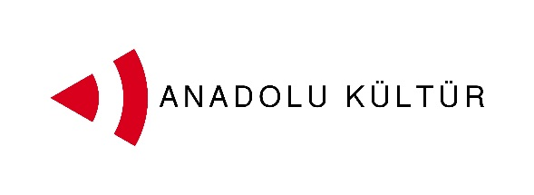
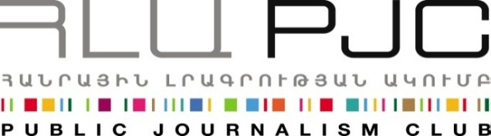
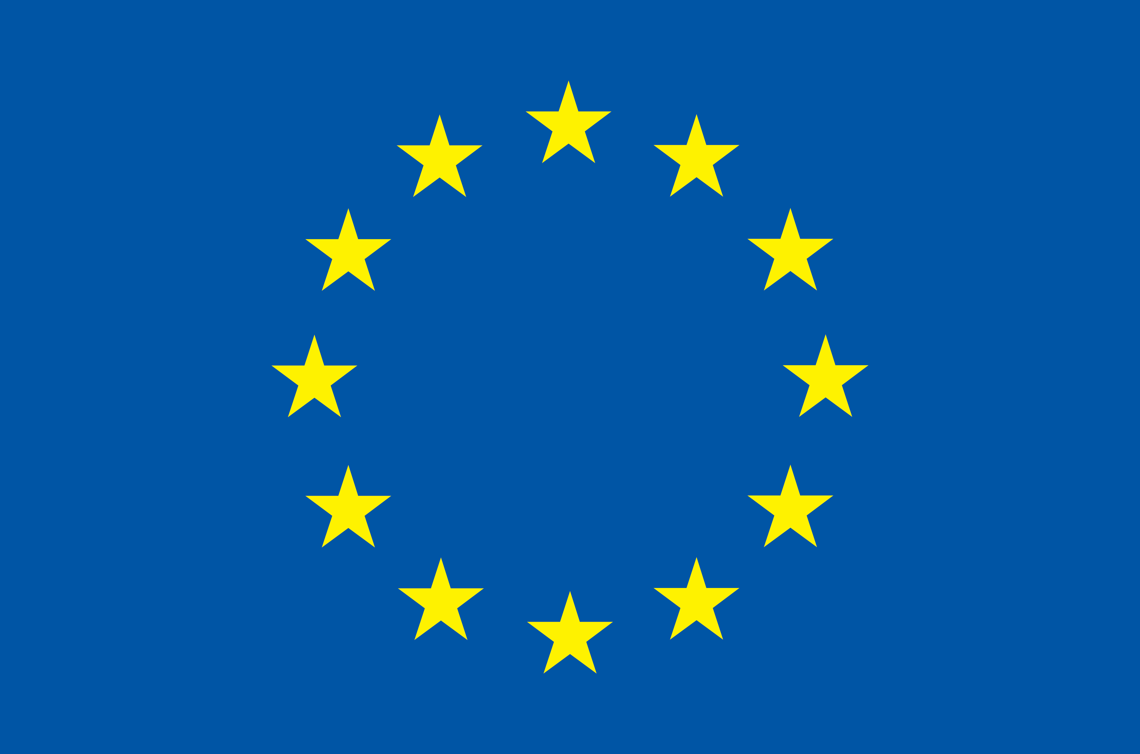
Europian Union

Press Release
Gyumri Hosts the Participants of the “Exchange of Painters” Project
Yerevan, 04.09.2014: On September 4th, the fourth day of the exchange, young painters from Turkey and Armenia participating in the “Exchange of Painters” project visited Gyumri.
The trip started with a tour of the National Museum of Architecture and Urban Life of Gyumri followed by a visit to the house museum of Sergei Merkurov. The groups then stopped at Berlin Art Hotel, where a master class was delivered by a young artist Karen Barseghyan from Gyumri, who presented his unique working technique to the project participants. The young painters were excited to experiment with this new technique that combined collage and painting elements with the use of different materials.
Karen Barseghyan born in 1979 in Gyumri. He graduated from the Yerevan Academy of Fine Arts in 2003. He has participated in a one month exchange program at Haystack Mountain School of Crafts, USA.
Barseghyan has shown his artworks in Armenia and Europe and has curated some exhibitions in Gyumri and VII Gyumri International Biennial. Barseghyan is co-founder of 15/3 art group (2007). He lives and works in Gyumri. His works are on permanent display at Berlin Art Hotel in Gyumri. Karen’s work was also shown in three solo exhibitions.
A tour of the central squares and streets of the city completed the visit to Gyumri.
The project was launched on September 1 and its activities will continue through September 7.
Culture is one of the possible tracks for promoting dialogue between the societies of Armenia and Turkey. More specifically, artistic activity can help an effective interchange since it does not need translation and mediation, and it transmits messages and creates bonds using the universal language of art. With this in mind the Public Journalism Club, in partnership with Anadolu Kültür, has launched the “Exchange of Painters” project focusing on the role of art in promoting Armenia-Turkey relations.
For inquires on project details please contact Ester Hakobyan at estherhakobyan@pjc.am and 098540804:
Public Journalism Club. mailto: info@pjc.am or call + 37460 505 898.
***
Support to the Armenia-Turkey Normalisation Process is a Programme implemented by a Consortium of eight civil society organisations from both countries with the financial assistance of the European Union under the Instrument for Stability.
The overall objective of the Programme is to promote civil society efforts towards the normalisation of relations between Turkey and Armenia and towards an open border by enhancing people-to-people contacts, expanding economic and business links, promoting cultural and educational activities and facilitating access to balanced information in both societies.
The Consortium partners include Civilitas Foundation (CF), Eurasia Partnership Foundation (EPF), Public Journalism Club (PJC), Regional Studies Center (RSC) from Armenia; and Anadolu Kültür, the Economic Policy Research Foundation of Turkey (TEPAV), Helsinki Citizens’ Assembly (hCa), and Hrant Dink Foundation from Turkey.
For further details on the programme and the project, please visit www.armenia-turkey.net

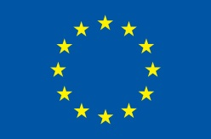
Support to the Armenia-Turkey Normalisation Process is funded by the European Union

