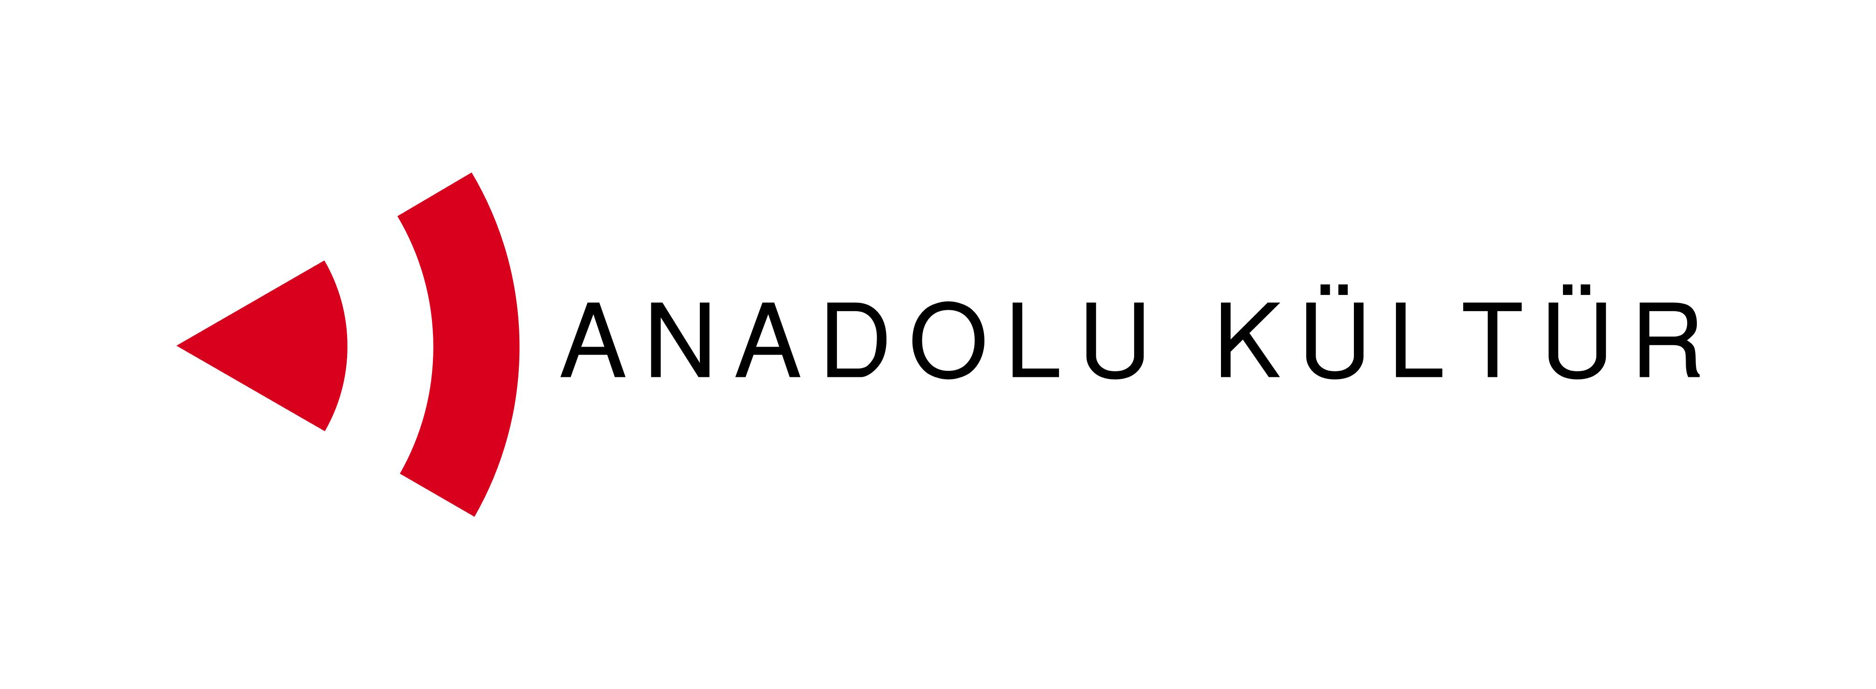
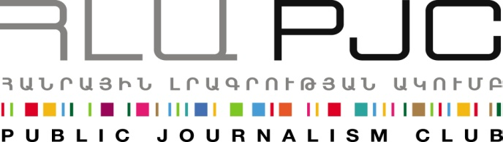

Press Release
Exchange of Painters Project: From the Art of Parajanov to Street Art
Yerevan, 06.09.2014: On September 6th, the group of participants of the “Exchange of Painters” project visited the Parajanov Museum, where Zaven Sargsyan, the museum director and an old friend of Parajanov, held a master class for the group focusing on the life and work of the renowned artist. Several of the project participants assessed this visit as one of the most memorable highlights of their week-long program.
Later during the day the young painters and Art Lab studio artists came together to paint an arch wall in Nalbandyan street based on a pre-developed sketch. Young painters had been tasked to propose ideas on a topic “Dialogue in the Language of Art”. On September 3rd they discussed their ideas together with Art Lab artists to select the concept acceptable for both groups and prepare the sketch. The final product were two sketches that used analogies of traffic signs to symbolize the idea of overcoming closed borders and moving toward each other.
The project was launched on September 1 and its activities will continue through September 7.
Culture is one of the possible tracks for promoting dialogue between the societies of Armenia and Turkey. More specifically, artistic activity can help an effective interchange since it does not need translation and mediation, and it transmits messages and creates bonds using the universal language of art. With this in mind the Public Journalism Club, in partnership with Anadolu Kültür, has launched the “Exchange of Painters” project focusing on the role of art in promoting Armenia-Turkey relations.
For inquires on project details please contact Ester Hakobyan at estherhakobyan@pjc.am and 098540804:
Public Journalism Club. mailto: info@pjc.am or call + 37460 505 898.
***
Support to the Armenia-Turkey Normalisation Process is a Programme implemented by a Consortium of eight civil society organisations from both countries with the financial assistance of the European Union under the Instrument for Stability.

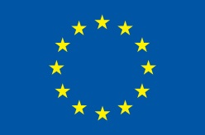

Support to the Armenia-Turkey Normalisation Process is funded by the European Union
The overall objective of the Programme is to promote civil society efforts towards the normalisation of relations between Turkey and Armenia and towards an open border by enhancing people-to-people contacts, expanding economic and business links, promoting cultural and educational activities and facilitating access to balanced information in both societies.

The Consortium partners include Civilitas Foundation (CF), Eurasia Partnership Foundation (EPF), Public Journalism Club (PJC), Regional Studies Center (RSC) from Armenia; and Anadolu Kültür, the Economic Policy Research Foundation of Turkey (TEPAV), Helsinki Citizens’ Assembly (hCa), and Hrant Dink Foundation from Turkey.
For further details on the programme and the project, please visit www.armenia-turkey.net

Support to the Armenia-Turkey Normalisation Process is funded by the European Union

