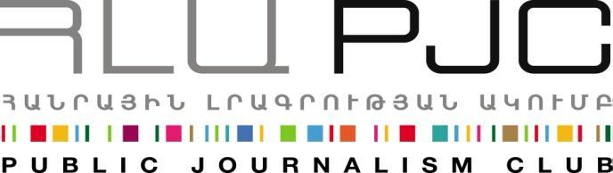

“Exchange of Entrepreneurs” Project

Startup Weekend
Startup Weekends are weekend-long, hands-on experiences where established and aspiring entrepreneurs can find out if startup ideas are viable. On average, half of Startup Weekend’s attendees have technical or design backgrounds, the other half have business backgrounds.
Beginning with open mic pitches, attendees bring their best ideas and inspire others to join their team. Over two days teams focus on customer development, validating their ideas, practicing LEAN Startup Methodologies and building a minimal viable product. As a result, teams demo their prototypes and receive valuable feedback from a panel of experts. Inclusion of investors in the event jury creates real opportunities for obtaining financial support for the ideas generated. As of April 2013, 1068 events had been held, involving over 100,000 entrepreneurs across more than 400 cities in over 100 countries and over 8190 startups have been created.
History
Founded in 2007 in Boulder, Colorado by Andrew Hyde Startup Weekend was initially created as an event where a group of individuals would brainstorm a single business idea and work to bring that business to fruition over the course of the weekend.
Event model
Startup Weekend events span the course of a weekend (approximately 54 hours), and are generally composed of 60-120 participants. In addition to attendees the event attracts speakers, coaches, panelists (generally well-respected members of the local and international startup community or notable names in the tech industry), and various sponsors and company representatives.

Why attend a Startup Weekend event?
There are dozens of reasons why you should come to a Startup Weekend! Since we know your time is valuable, we’ll only list the top seven:
Education:
Startup Weekends are all about learning through the act of creating. Don’t just listen to theory, build your own strategy and test it as you go.
Build your network:
This isn’t just a happy-hour. Startup Weekend attracts your community’s best makers and do-ers. By spending a weekend working to build scalable companies that solve real-world problems, you will build long-lasting relationships and possibly walk away with a job or even an investor.
Co-Founder Dating:
We all know it’s not just about the idea – it’s about the team. Startup Weekend is hands down the best way to find someone you can actually launch a startup with.
Learn a new skill:
Step outside of your comfort zone. With a whole weekend dedicated to letting your creative juices flow, Startup Weekends are perfect opportunities to work on a new platform, learn a new programming language, or just try something different.
Actually launch a business:
Over 36% of Startup Weekend startups are still going strong after 3 months. Roughly 80% of participants plan on continuing working with their team or startup after the weekend.
Get face time with thought leaders:
Local tech and startup leaders participate in Startup Weekends as coaches and judges. Get some one-on-one time with the movers and shakers in your community.
Join a global community:
Join over 45,000 Startup Weekend alumni, all on a mission to change the world.

